**US CRIME ANALYSIS**

Create a SQL database containing data related to the case number, primary crime category, crime description, crime location, and arrest status using the dataset.

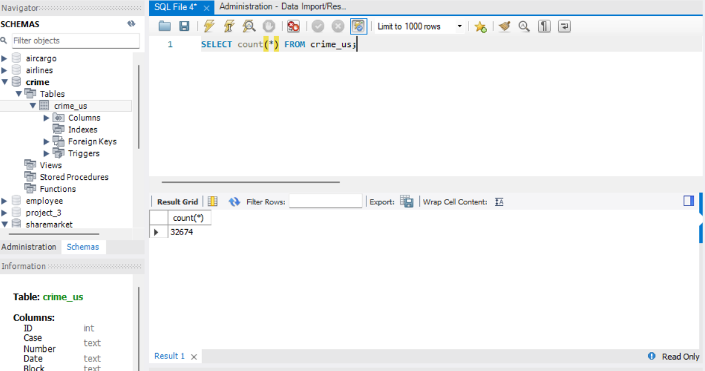

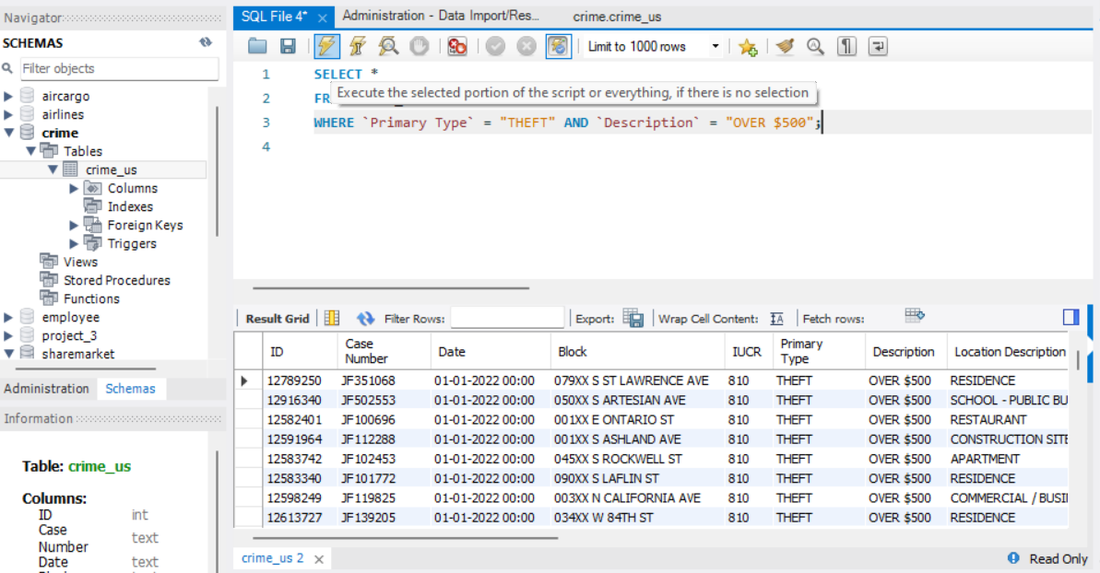

Make a database in SQL where theft costs more than $500.

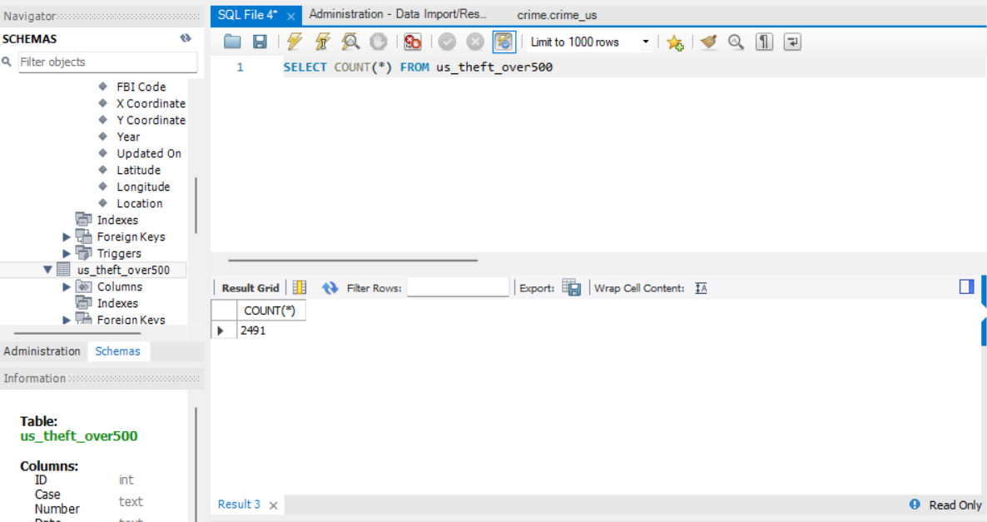

Determine the overall number of cases for each major category of crime.

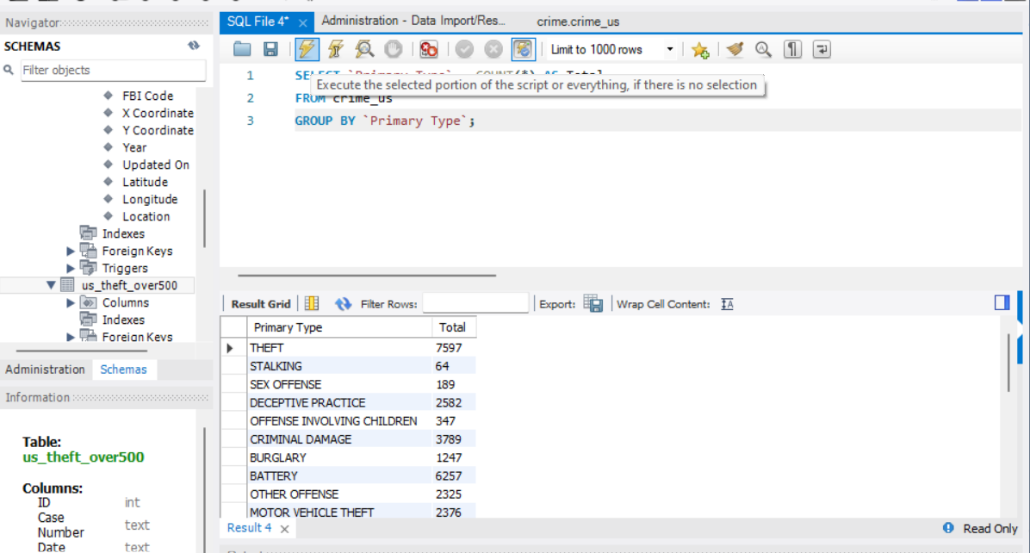

Apply 1NF normalization to the dataset provided.

